**ANDROID APPLICATION DEVELOPMENT**

**ENDSEM**

RITIKA LIZ RENGIT CH.EN.U4CYS21066

Experiment No 1:   
1. Create an form to enter I. Company name II. Description III. Founded Date 2. Save it 3. Immediately after saving, the company name should be displayed in the next page. 4. Enter like that for 5 company (Apple, Google, Microsoft, Amrita, Meta) and then in a fresh activity 5. Display all the companies details. 6. Create a Search View and if your press ‘G’ then only Google details should be displayed 7. Storage should be done in SQLite and Firebase

**MainActivity.java**

package com.ritika.endsemproj;  
  
import android.os.Bundle;  
import android.webkit.WebView;  
import android.webkit.WebViewClient;  
  
import androidx.activity.EdgeToEdge;  
import androidx.appcompat.app.AppCompatActivity;  
import androidx.core.graphics.Insets;  
import androidx.core.view.ViewCompat;  
import androidx.core.view.WindowInsetsCompat;  
  
public class MainActivity extends AppCompatActivity {  
  
 @Override  
 protected void onCreate(Bundle savedInstanceState) {  
 super.onCreate(savedInstanceState);  
 EdgeToEdge.*enable*(this);  
 setContentView(R.layout.*activity_main*);  
  
 WebView webView = findViewById(R.id.*main*);  
 webView.setWebViewClient(new WebViewClient());  
 webView.loadUrl("http://11.12.4.255:5000");  
  
 ViewCompat.*setOnApplyWindowInsetsListener*(findViewById(R.id.*main*), (v, insets) -> {  
 Insets systemBars = insets.getInsets(WindowInsetsCompat.Type.*systemBars*());  
 v.setPadding(systemBars.left, systemBars.top, systemBars.right, systemBars.bottom);  
 return insets;  
 });  
 }  
}

**AndroidManifest.xml**

<?xml version="1.0" encoding="utf-8"?>  
<manifest xmlns:android="http://schemas.android.com/apk/res/android"  
 xmlns:tools="http://schemas.android.com/tools">  
  
 <uses-permission android:name="android.permission.INTERNET"/>  
  
 <application  
 android:allowBackup="true"  
 android:dataExtractionRules="@xml/data_extraction_rules"  
 android:fullBackupContent="@xml/backup_rules"  
 android:icon="@mipmap/ic_launcher"  
 android:label="@string/app_name"  
 android:roundIcon="@mipmap/ic_launcher_round"  
 android:supportsRtl="true"  
 android:theme="@style/Theme.EndSemProj"  
 tools:targetApi="31">  
 <activity  
 android:name=".MainActivity"  
 android:exported="true">  
 <intent-filter>  
 <action android:name="android.intent.action.MAIN" />  
  
 <category android:name="android.intent.category.LAUNCHER" />  
 </intent-filter>  
 </activity>  
 </application>  
</manifest>

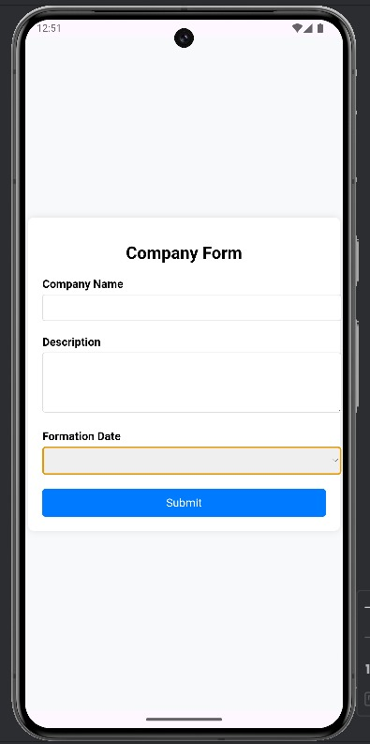 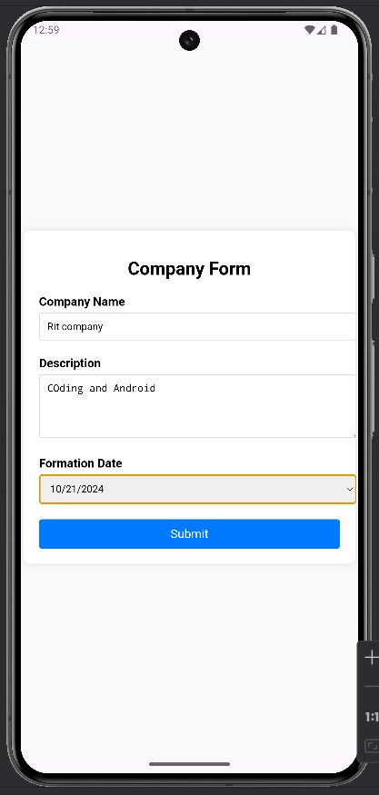

**activity_main.xml**  
<?xml version="1.0" encoding="utf-8"?>  
<androidx.constraintlayout.widget.ConstraintLayout xmlns:android="http://schemas.android.com/apk/res/android"  
 xmlns:app="http://schemas.android.com/apk/res-auto"  
 xmlns:tools="http://schemas.android.com/tools"  
 android:id="@+id/main"  
 android:layout_width="match_parent"  
 android:layout_height="match_parent"  
 tools:context=".MainActivity">  
  
 <WebView  
 android:layout_width="409dp"  
 android:layout_height="729dp"  
 tools:layout_editor_absoluteX="1dp"  
 tools:layout_editor_absoluteY="1dp"  
 tools:ignore="MissingConstraints" />  
</androidx.constraintlayout.widget.ConstraintLayout>

**activity_search.xml**<?xml version="1.0" encoding="utf-8"?>  
<RelativeLayout xmlns:android="http://schemas.android.com/apk/res/android"  
 android:layout_width="match_parent"  
 android:layout_height="match_parent">  
  
 <TextView  
 android:id="@+id/searchTextView"  
 android:layout_width="wrap_content"  
 android:layout_height="wrap_content"  
 android:textSize="24sp"  
 android:layout_centerInParent="true"/>  
</RelativeLayout>

**activity_company_detail.xml**<?xml version="1.0" encoding="utf-8"?>  
<RelativeLayout xmlns:android="http://schemas.android.com/apk/res/android"  
 android:layout_width="match_parent"  
 android:layout_height="match_parent">  
  
 <TextView  
 android:id="@+id/companyNameTextView"  
 android:layout_width="wrap_content"  
 android:layout_height="wrap_content"  
 android:textSize="24sp"  
 android:layout_margin="16dp"/>  
  
 <TextView  
 android:id="@+id/companyDescriptionTextView"  
 android:layout_width="wrap_content"  
 android:layout_height="wrap_content"  
 android:layout_below="@id/companyNameTextView"  
 android:textSize="18sp"  
 android:layout_margin="16dp"/>  
</RelativeLayout>

**activity_all_companies.xml**<!-- activity_all_companies.xml -->  
<RelativeLayout xmlns:android="http://schemas.android.com/apk/res/android"  
 android:layout_width="match_parent"  
 android:layout_height="match_parent">  
  
 <SearchView  
 android:id="@+id/searchView"  
 android:layout_width="match_parent"  
 android:layout_height="wrap_content" />  
  
 <ListView  
 android:id="@+id/companiesListView"  
 android:layout_width="match_parent"  
 android:layout_height="wrap_content"  
 android:layout_below="@id/searchView" />  
  
 <TextView  
 android:layout_width="wrap_content"  
 android:layout_height="wrap_content"  
 android:layout_alignParentEnd="true"  
 android:text="RITIKA 21066" />  
</RelativeLayout>

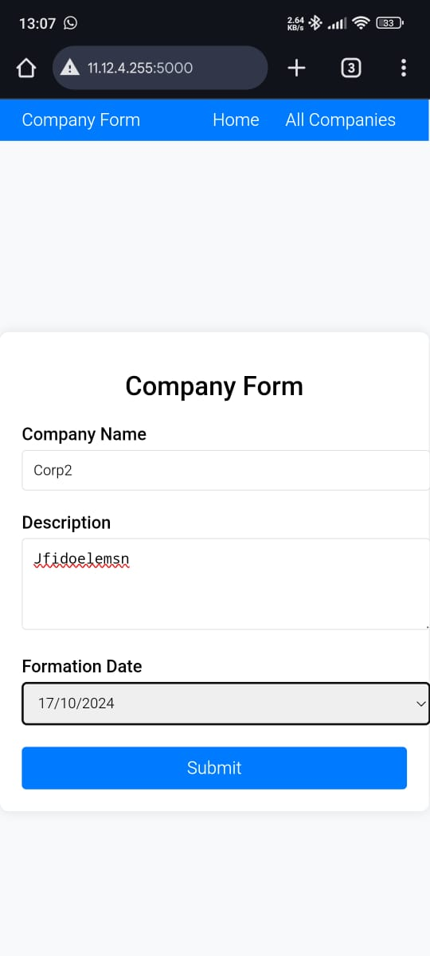 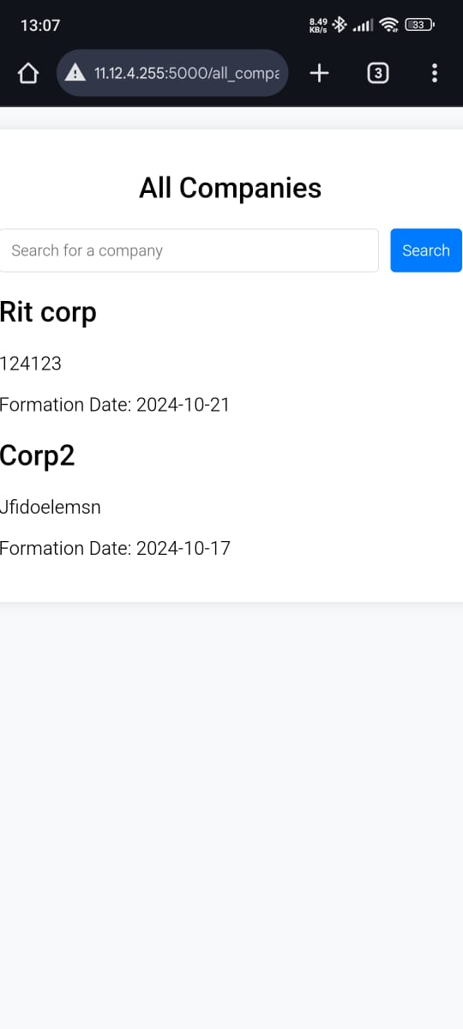 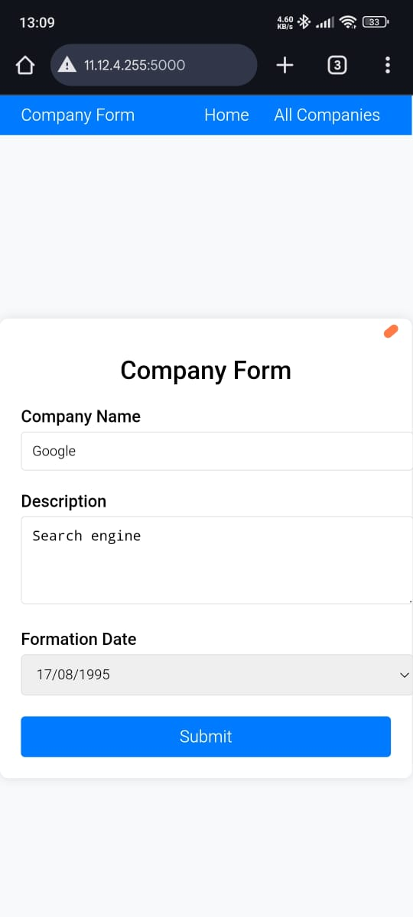 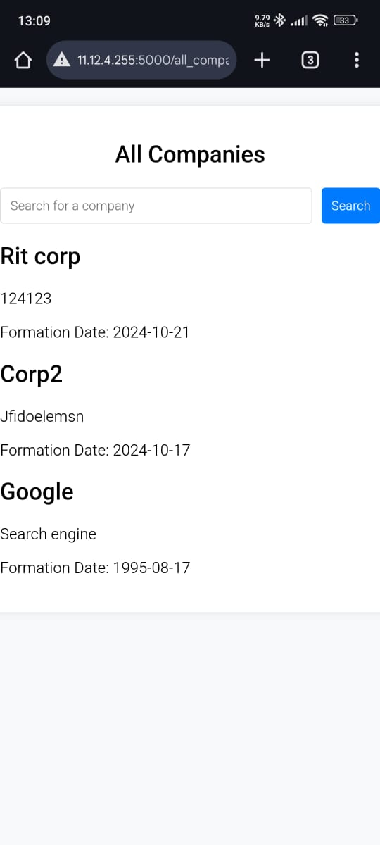

**styels.xml**

<resources>  
 <!-- Base application theme -->  
 <style name="Theme.EndsemPages" parent="Theme.MaterialComponents.DayNight.DarkActionBar">  
 <!-- Customize your theme here -->  
 <item name="colorPrimary">@color/purple_500</item>  
 <item name="colorPrimaryVariant">@color/red_900</item>  
 <item name="colorOnPrimary">@android:color/white</item>  
 <item name="colorSecondary">@color/teal_200</item>  
 <item name="colorOnSecondary">@android:color/black</item>  
 <item name="android:windowBackground">@android:color/white</item>  
 </style>  
</resources>

**AllCompaniesActivity.java**

// AllCompaniesActivity.java  
package com.example.endsemfinal;  
  
import android.os.Bundle;  
import android.widget.ArrayAdapter;  
import android.widget.ListView;  
import android.widget.SearchView;  
import androidx.appcompat.app.AppCompatActivity;  
import java.util.ArrayList;  
  
public class AllCompaniesActivity extends AppCompatActivity {  
  
 private ListView companiesListView;  
 private SearchView searchView;  
 private ArrayAdapter<String> adapter;  
 private ArrayList<String> companyNames = new ArrayList<>();  
  
 @Override  
 protected void onCreate(Bundle savedInstanceState) {  
 super.onCreate(savedInstanceState);  
 setContentView(R.layout.activity_all_companies);  
  
 // Initialize views  
 companiesListView = findViewById(R.id.companiesListView);  
 searchView = findViewById(R.id.searchView);  
  
 // Populate company names  
 for (Company company : MainActivity.companyList) {  
 companyNames.add(company.getName());  
 }  
  
 // Set up adapter  
 adapter = new ArrayAdapter<>(this, android.R.layout.*simple_list_item_1*, companyNames);  
 companiesListView.setAdapter(adapter);  
  
 // Search functionality  
 searchView.setOnQueryTextListener(new SearchView.OnQueryTextListener() {  
 @Override  
 public boolean onQueryTextSubmit(String query) {  
 return false;  
 }  
  
 @Override  
 public boolean onQueryTextChange(String newText) {  
 adapter.getFilter().filter(newText);  
 return false;  
 }  
 });  
 }  
}

**Company.java**

<?xml version="1.0" encoding="utf-8"?>  
<RelativeLayout xmlns:android="http://schemas.android.com/apk/res/android"  
android:layout_width="match_parent"  
android:layout_height="match_parent">  
  
 <ListView  
android:id="@+id/companiesListView"  
android:layout_width="match_parent"  
android:layout_height="match_parent"/>  
</RelativeLayout>

**MainActivity.java**

// MainActivity.java  
package com.example.endsemfinal;  
  
import android.content.Intent;  
import android.os.Bundle;  
import android.view.View;  
import android.widget.Button;  
import android.widget.EditText;  
import androidx.appcompat.app.AppCompatActivity;  
import java.util.ArrayList;  
  
public class MainActivity extends AppCompatActivity {  
  
 private EditText companyName, description, foundedDate;  
 private Button saveButton;  
 public static ArrayList<Company> *companyList* = new ArrayList<>();  
  
 @Override  
 protected void onCreate(Bundle savedInstanceState) {  
 super.onCreate(savedInstanceState);  
 setContentView(R.layout.activity_main);  
  
 // Initialize views  
 companyName = findViewById(R.id.companyName);  
 description = findViewById(R.id.description);  
 foundedDate = findViewById(R.id.foundedDate);  
 saveButton = findViewById(R.id.saveButton);  
  
 saveButton.setOnClickListener(new View.OnClickListener() {  
 @Override  
 public void onClick(View v) {  
 // Save company details  
 String name = companyName.getText().toString();  
 String desc = description.getText().toString();  
 String date = foundedDate.getText().toString();  
  
 *companyList*.add(new Company(name, desc, date));  
  
 // Open DisplayCompanyActivity and pass the company name  
 Intent intent = new Intent(MainActivity.this, DisplayCompanyActivity.class);  
 intent.putExtra("companyName", name);  
 startActivity(intent);  
 }  
 });  
 }  
}

**DBHelper.java**

package com.example.endsemfinal;  
  
import android.content.Context;  
import android.database.sqlite.SQLiteDatabase;  
import android.database.sqlite.SQLiteOpenHelper;  
  
public class DBHelper extends SQLiteOpenHelper {  
  
 private static final String *DATABASE_NAME* = "endsem.db";  
 private static final int *DATABASE_VERSION* = 1;  
  
 public DBHelper(Context context) {  
 super(context, *DATABASE_NAME*, null, *DATABASE_VERSION*);  
 }  
  
 @Override  
 public void onCreate(SQLiteDatabase db) {  
 // Create tables here  
 db.execSQL("CREATE TABLE IF NOT EXISTS users (id INTEGER PRIMARY KEY, name TEXT, email TEXT)");  
 }  
  
 @Override  
 public void onUpgrade(SQLiteDatabase db, int oldVersion, int newVersion) {  
 db.execSQL("DROP TABLE IF EXISTS users");  
 onCreate(db);  
 }  
}

**FirebaseHelper.java**package com.example.endsemfinal;  
  
import com.google.firebase.database.DatabaseReference;  
import com.google.firebase.database.FirebaseDatabase;  
  
public class FirebaseHelper {  
 private DatabaseReference databaseReference;  
  
 public FirebaseHelper() {  
 databaseReference = FirebaseDatabase.getInstance().getReference("users");  
 }  
  
 // Add more methods to handle Firebase operations as needed  
}

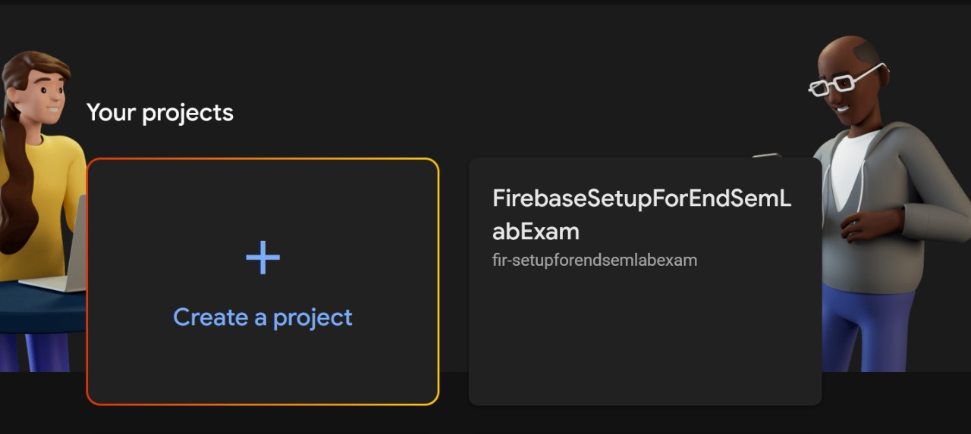

**SearchActivity.java**

package com.example.endsemfinal;  
  
import android.content.Intent;  
import android.os.Bundle;  
import android.view.View;  
import android.widget.Button;  
  
import androidx.appcompat.app.AppCompatActivity;  
  
public class MainActivity extends AppCompatActivity {  
  
 @Override  
 protected void onCreate(Bundle savedInstanceState) {  
 super.onCreate(savedInstanceState);  
 setContentView(R.layout.activity_main);  
  
 Button searchButton = findViewById(R.id.searchButton);  
 searchButton.setOnClickListener(new View.OnClickListener() {  
 @Override  
 public void onClick(View v) {  
 Intent intent = new Intent(MainActivity.this, SearchActivity.class);  
 startActivity(intent);  
 }  
 });  
 }  
}

**INDEX.HTML**

<!DOCTYPE html>

<html lang="en">

<head>

    <meta charset="UTF-8">

    <meta name="viewport" content="width=device-width, initial-scale=1.0">

    <title>Company Form</title>

    <style>

        body {

            font-family: Arial, sans-serif;

            margin: 0;

            padding: 0;

            background-color: #f8f9fa;

        }

        .navbar {

            display: flex;

            justify-content: space-between;

            align-items: center;

            padding: 10px 20px;

            background-color: #007bff;

            color: white;

        }

        .navbar a {

            color: white;

            text-decoration: none;

            margin: 0 10px;

        }

        .container {

            display: flex;

            justify-content: center;

            align-items: center;

            height: calc(100vh - 50px);

        }

        .form-container {

            width: 100%;

            max-width: 400px;

            padding: 20px;

            background-color: #fff;

            box-shadow: 0 0 10px rgba(0,0,0,0.1);

            border-radius: 8px;

        }

        h1 {

            font-size: 24px;

            margin-bottom: 20px;

            text-align: center;

        }

        .form-group {

            margin-bottom: 15px;

        }

        label {

            display: block;

            margin-bottom: 5px;

            font-weight: bold;

        }

        input[type="text"], input[type="date"], textarea {

            width: 100%;

            padding: 10px;

            margin-bottom: 5px;

            border: 1px solid #ddd;

            border-radius: 4px;

        }

        button {

            width: 100%;

            padding: 10px;

            background-color: #007bff;

            border: none;

            color: white;

            border-radius: 4px;

            font-size: 16px;

        }

    </style>

</head>

<body>

    <div class="navbar">

        <div>Company Form</div>

        <div>

            <a href="/">Home</a>

            <a href="/all_companies">All Companies</a>

        </div>

    </div>

    <div class="container">

        <div class="form-container">

            <h1>Company Form</h1>

            <form action="/submit" method="post">

                <div class="form-group">

                    <label for="companyName">Company Name</label>

                    <input type="text" id="companyName" name="companyName" required>

                </div>

                <div class="form-group">

                    <label for="description">Description</label>

                    <textarea id="description" name="description" rows="4" required></textarea>

                </div>

                <div class="form-group">

                    <label for="formationDate">Formation Date</label>

                    <input type="date" id="formationDate" name="formationDate" required>

                </div>

                <button type="submit">Submit</button>

            </form>

        </div>

    </div>

</body>

</html>

**APP.PY**

from flask import Flask, request, render_template, redirect, url_for

app = Flask(__name__)

companies = []

@app.route('/')

def index():

    return render_template('index.html')

@app.route('/submit', methods=['POST'])

def submit():

    company = {

        "name": request.form['companyName'],

        "description": request.form['description'],

        "formation_date": request.form['formationDate']

    }

    companies.append(company)

    return redirect(url_for('company_name', company_name=company['name']))

@app.route('/company/<company_name>')

def company_name(company_name):

    return f"Company saved: {company_name}"

@app.route('/all_companies')

def all_companies():

    return render_template('all_companies.html', companies=companies)

@app.route('/search', methods=['GET', 'POST'])

def search():

    search_term = request.form.get('search_term', '')

    results = [company for company in companies if company['name'].startswith(search_term)]

    return render_template('all_companies.html', companies=results)

app.run(host='0.0.0.0')

**ALL_COMPANIES.HTML**

<!DOCTYPE html>

<html lang="en">

<head>

    <meta charset="UTF-8">

    <meta name="viewport" content="width=device-width, initial-scale=1.0">

    <title>All Companies</title>

    <style>

        body {

            font-family: Arial, sans-serif;

            margin: 0;

            padding: 0;

            display: flex;

            flex-direction: column;

            align-items: center;

            background-color: #f8f9fa;

        }

        .container {

            width: 100%;

            max-width: 600px;

            margin: 20px;

            padding: 20px;

            background-color: #fff;

            box-shadow: 0 0 10px rgba(0,0,0,0.1);

            border-radius: 8px;

        }

        h1 {

            font-size: 24px;

            margin-bottom: 20px;

            text-align: center;

        }

        .company {

            margin-bottom: 15px;

        }

        form {

            width: 100%;

            display: flex;

            margin-bottom: 20px;

        }

        input[type="text"] {

            flex: 1;

            padding: 10px;

            border: 1px solid #ddd;

            border-radius: 4px;

        }

        button {

            padding: 10px;

            background-color: #007bff;

            border: none;

            color: white;

            border-radius: 4px;

            margin-left: 10px;

        }

    </style>

</head>

<body>

    <div class="container">

        <h1>All Companies</h1>

        <form action="/search" method="post">

            <input type="text" name="search_term" placeholder="Search for a company">

            <button type="submit">Search</button>

        </form>

        {% for company in companies %}

        <div class="company">

            <h2>{{ company.name }}</h2>

            <p>{{ company.description }}</p>

            <p>Formation Date: {{ company.formation_date }}</p>

        </div>

        {% endfor %}

    </div>

</body>

</html>

**SHOW_COMPANIES.HTML**

<!DOCTYPE html>

<html lang="en">

<head>

    <meta charset="UTF-8">

    <meta name="viewport" content="width=device-width, initial-scale=1.0">

    <title>Saved Companies</title>

    <style>

        body {

            font-family: Arial, sans-serif;

            margin: 0;

            padding: 0;

            display: flex;

            justify-content: center;

            align-items: center;

            height: 100vh;

            background-color: #f8f9fa;

        }

        .container {

            width: 100%;

            max-width: 400px;

            padding: 20px;

            background-color: #fff;

            box-shadow: 0 0 10px rgba(0,0,0,0.1);

            border-radius: 8px;

        }

        h1 {

            font-size: 24px;

            margin-bottom: 20px;

            text-align: center;

        }

        ul {

            list-style-type: none;

            padding: 0;

        }

        li {

            background-color: #007bff;

            color: white;

            padding: 10px;

            margin-bottom: 10px;

            border-radius: 4px;

        }

    </style>

</head>

<body>

    <div class="container">

        <h1>Saved Companies</h1>

        <ul>

            {% for company in companies %}

                <li>{{ company['name'] }}</li>

            {% endfor %}

        </ul>

    </div>

</body>

</html>